<https://resources.curve.fi/governance/understanding-governance>

**Understanding Governance**

**Voting on the Curve DAO**

To vote on the Curve DAO, users need to lock vote lock their CRV. By doing so, participants can earn a boost on their provided liquidity and vote on all DAO proposals. Users who reach a voting power of 2500 veCRV can also create new proposals. There is no minimum voting power required to vote.

**Voting Power**

veCRV stands for vote escrowed CRV, it's a locker where users can lock their CRV for different lengths of time to gain voting power. Users can lock their CRV for a minimum of week and a maximum of four years. As users with long voting escrow have more stake, they receive more voting power.

**The DAO Dashboard**

You can visit the Curve DAO dashboard at this address: <https://dao.curve.fi/dao>​

On this page, you can find all current and closed votes. All proposals should have a topic on the Curve governance forum at this address: <https://gov.curve.fi/>​

**Submitting proposals**

If you wish to create a new official proposal, you should draft a proposal and post it on the governance forum. You must also research that it's possible and gauge interest of the community via the Curve Discord, Telegram or Governance forum.

If you're not sure about the technical details of submitting your proposal to the Ethereum blockchain, you can ask a member of the team to help.

# Vote Locking

Answering all your burning questions about the vote locking boost

## What is vote locking?

CRV holders can vote lock their CRV into the Curve DAO to receive veCRV. The longer they lock for, the more veCRV they receive. Vote locking allows you to vote in governance, boost your CRV rewards and receive trading fees.

## What is the vote locking boost?

When vote locking CRV, you will also earn a boost on your provided liquidity of up to 2.5x. The goal is to incentivise users to participate in governance by rewarding them with a bigger share of the daily CRV inflation.

## When does the boost start?

The boost will start on the 26th of August 2020 around 11pm UTC.

## What are veCRV?

veCRV stands for voting escrow CRV. They are your CRV locked for voting. The longer you lock your CRV for, the more voting power you have (and the bigger boost you can reach). You can vote lock 1,000 CRV for a year to have a 250 veCRV weight. Each CRV locked for four years is equal to 1 veCRV.

The number of veCRV you will receive depends on how long you lock your CRV for. The minimum locking time is one week and the maximum locking time is four years.

Your veCRV weight gradually decreases as your escrowed tokens approach their lock expiry. A graph illustrating the decrease can be found at this address: <https://dao.curve.fi/locker>​

## How is your boost calculated?

To reach your maximum boost of 2.5x, there are several parameters to take into consideration.

You can find the current DAO voting power at this address: <https://dao.curve.fi/locker>​

**You can find a calculator at this address:** <https://dao.curve.fi/minter/calc>​

## What if I provide liquidity in multiple pools?

Your voting power applies to all gauges but may produce different boosts based on how much liquidity you are providing and how much total liquidity the pool has.

## What happens if more people vote lock?

If other liquidity providers vote lock more CRV, your boost will stay what it was when you applied it. If you abuse this, another user can kick and force a boost update to take you down to your real boost.

## How often does my boost records voting power changes?

Your voting weight decreases over time but your boost will take notice of your decreasing voting power at certain checkpoints like withdrawing, depositing into a gauge or minting CRV.

For example if you start at 1000 veCRV and your voting power decreases to 800 veCRV, your boost will still use your original voting power of 1000 veCRV until a user checkpoint.

## How can I apply my boost?

After creating or adding to your lock, you need to click the apply boost button to update your boost on each of the gauge you're providing liquidity in. Your boost can also be updated by depositing or withdrawing from a gauge.

Click below for a guide on how locking and boosting your CRV rewards

[Boosting your CRV Rewards](https://resources.curve.fi/reward-gauges/boosting-your-crv-rewards)

## How to know my boost is active?

If your boost is showing then it is active.

If you have locked but your boost isn't showing then you need to apply it.

**Voting**

**How to participate in governance?**

To participate in governance, Curve Finance users need to lock their CRV into a voting escrow.

You can do so at this address: <https://dao.curve.fi/locker>​

**What are veCRV?**

veCRV stands for voting escrow CRV. They are your CRV locked for voting. The longer you lock your CRV for, the more voting power you have (and the bigger boost you can reach). You can vote lock 1,000 CRV for a year to have a 250 veCRV weight.

Your veCRV weight gradually decreases as your escrowed tokens approach their lock expiry. A graph illustrating the decrease can be found at this address: <https://dao.curve.fi/locker>​

Get more voting power by locking your CRV for a longer period of time.

**Can I start voting right away?**

You can only vote using your voting weight at the block where a proposal was created.

**How to vote?**

Simply visit the proposal of your choice, click your vote option and confirm your transaction. You can find DAO proposals at this address: <https://dao.curve.fi/dao>​

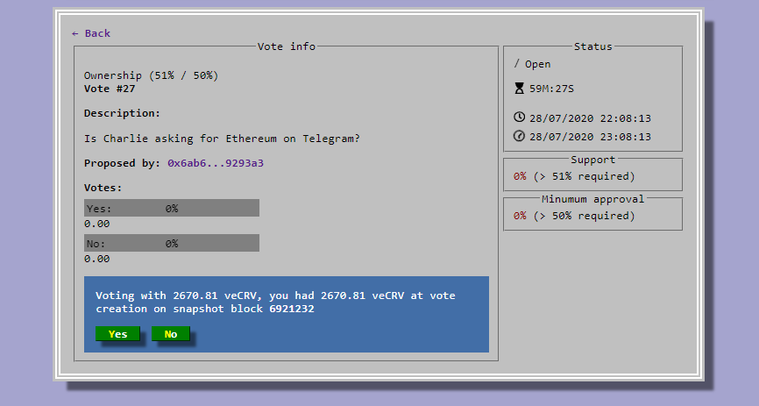

**Where can I find out about governance?**

You can visit the Curve Finance governance forum at this address <http://gov.curve.fi/>

**Snapshot**

Snapshot is a signalling tool that allows governance participants to signal for free.

As gas fees are here to stay on the Ethereum blockchain, Curve governance is now using a tool called Snapshot to allow governance users to signal their preferences on Curve proposals.

Whilst this tool doesn't replace governance and will only be used to signal, it's a great way for holders of all sizes to make their voices heard as **voting is completely free.**

**Voting**

Head over to the signalling tool: <https://signal.curve.fi/#/curve> and connect your Metamask wallet. It should be the one where you hold your veCRV (vote locked CRV).

Simply review your proposal, select your preferred option and click Vote:

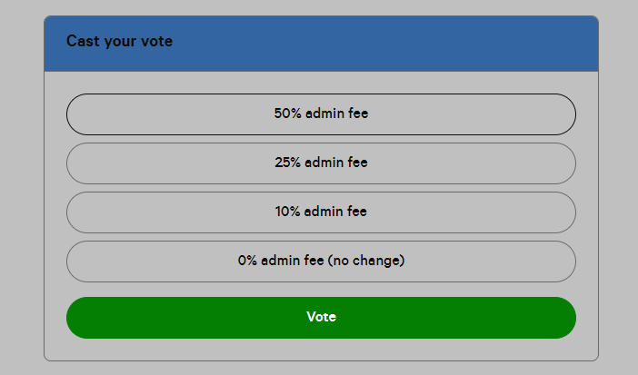

You will be prompted by Metamask to sign a transaction which is completely free and your voting vote will be counted according to your voting weight at the moment of the proposal creation.

# Proposals

Once CRV holders vote-lock their veCRV, they can start voting on various proposals.

## Creating a proposal

Anybody can create proposals but users need to follow the structure of a proposal which can be found by creating a new topic on the governance forum: <https://gov.curve.fi/>​

Users who create proposals also need to create a corresponding CIP proposal at <http://signal.curve.fi/>​

Using the signalling tool is completely free (no transaction fees) and you only need 1veCRV to create a proposal there.

Assuming you have at least 2,500 veCRV, you can also create an official DAO vote as long as it also comes with its topic presenting it on the governance forum.

[Voting](https://resources.curve.fi/governance/voting)

​

## Type of votes

Currently there are two type of votes:

* Signalling votes which are non-official votes only used to gauge interest from community (<https://signal.curve.fi/#/>)
* Official DAO votes are the only way to enact changes on the Curve protocol (<https://dao.curve.fi/>)

# Community Fund

CRV initial distribution allowed for a community fund of around $151M to be used in cases of emergencies or awarded to community-lead initiatives.

The Curve DAO can decide to award part of this fund through a proposal.

[Creating a DAO proposal](https://resources.curve.fi/governance/proposals/creating-a-dao-proposal)

If you have a project you feel is deserving a grant, please create a proposal or come discuss it with a team member on Discord or Telegram.

**Creating a DAO proposal**

Official DAO proposals are the only way to create enforceable change on the Curve protocol. There are currently two type of votes: parameter and text.

Parameter votes are automatically committed to the DAO three days after they are enacted at the end of the vote（参数投票在投票结束时生效三天后自动提交给DAO）. Text proposals are different as they will often necessitate development（需要开发）. For those, it is recommended to discuss with the Curve team to understand feasibility and create a signalling proposal.

To create a new DAO proposal, **you need at least 2,500 veCRV** (2,500 CRV locked for four years or 10,000 CRV locked for one year).

**Creating your vote**

Visit the Curve DAO: <https://dao.curve.fi/dao>, select your type of vote and submit it.

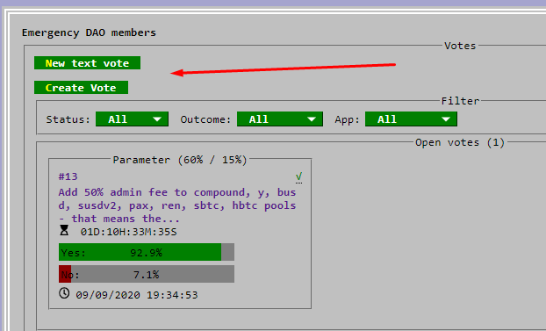

**Creating your proposal**

Every DAO proposal must be accompanied with a proposal on the Curve governance forum. Visit the proposal section: <https://gov.curve.fi/c/proposals/8> and click **"New Topic"**.

You will then be presented with a template to help you present your proposed choices to the community.

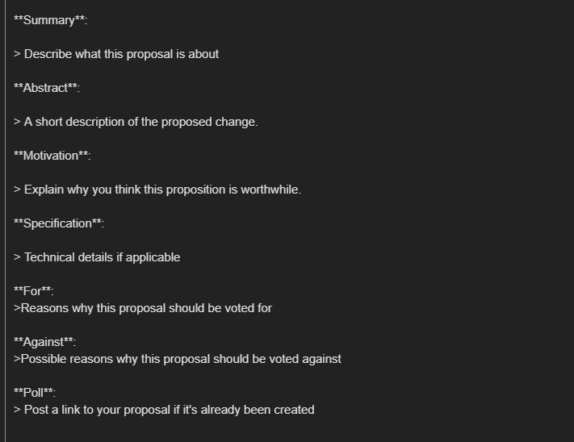

After that's done, be sure to engage with members of the community who have questions about your proposal.